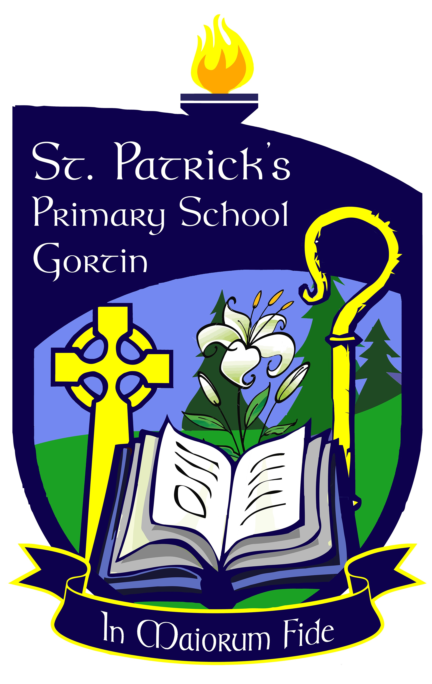

PARENTS NEWSLETTER FEBRUARY 2017

FUNRUN- 8th APRIL 2017

We are hoping once again to secure lots of new sponsorship for our Funrun this year and would welcome any suggestions or offers! The first Committee Meeting to help organise the Funrun was held on the 31st of January in Gortin Controlled Primary School. We hope to welcome more new faces from St Patrick’s at our next meeting, which will be held in St Patrick’s - on Tuesday 21st February at 7.30p.m.

NON-UNIFORM DAY

Our next non-uniform day will be on Tuesday 14th February- red or pink for Valentine’s Day! Donations - £1 per pupil and all proceeds will go towards Planting Boxes for each classroom, made locally by Gortin Mens’ Shed.

CATHOLIC EDUCATION WEEK

Beginning Monday 30th January. The theme this year is “Learning with Pope Francis to care for our common home”. All pupils will be taking part in a variety of activities during this week which hopefully pupils will share with you. They will finish the week off attending First Friday Mass on Friday morning. You are all very welcome to join us.

GRANDPARENTS’ COFFEE MORNING FRIDAY 10th FEBRUARY AT 11AM IN SCHOOL HALL

To get an idea of how many Grandparents we are catering for, it is essential that you fill out the slip and forward to the school by Friday 3rd February. Please also remember to forward a little photograph of any Grandparent who has sadly passed away so that they can be remembered on this special day.

WAYS A PARENT CAN HELP WITH READING

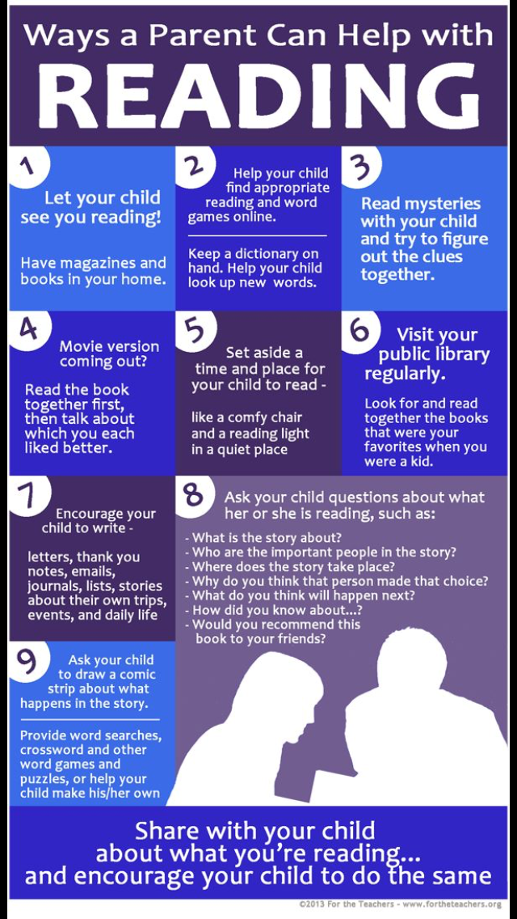

HEALTHY HOMEWORK – some great tips

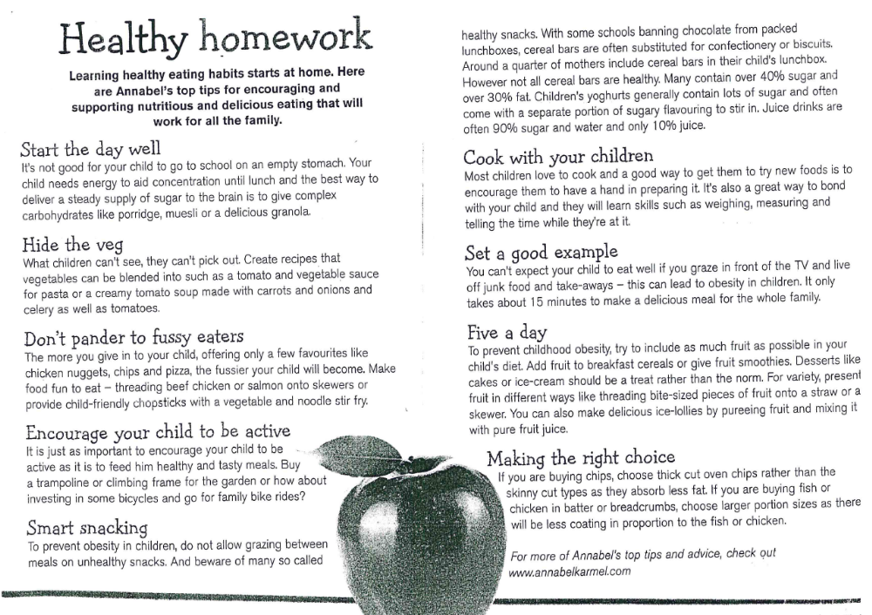

BREAKFAST CLUB

Ten families benefited from our January initiative of “5 days for the price of 4” – we hope to run this again throughout the year.

E-SAFETY DAY – 7TH FEBRUARY

Please see attached leaflet regarding e-safety in the home. Please also monitor the apps your child is accessing at home and talk to your child about the importance of telling them if someone’s online behaviour made them scared or uncomfortable. There has been recent concern reported regarding the App “Live.ly” – a video streaming chat App. This is an unsafe App for children to use.

PRINCIPAL AWARDS – For spreading joy in the new year!

P1 – Alex Bunting & Erinn McCullagh
P2 – Aine McCreanor
P3 - Caoimhe O’Kane & Lucy McCrossan
P4 – Tia-Mae Masumba , Ronan McCullagh & S.J.McCullagh
P6 – Corey Masumba & Aoife Marlow
P7 – Keeley McCullagh & Liam-Og Mossey & Sean McGarvey

INDOOR FOOTBALL BLITZ

We will be sending a 5 a side football team to the Cumann Na Bunscoil indoor boys blitz on Wednesday 1st February – all pupils involved please wear PE Uniform and bring a packed lunch. The girls’ blitz will take place on Monday 20th February.

BADONEY DEVELOPMENT PARTNERSHIP – Community Friendship Programme.

The first session of this joint schools Foundation Stage Programme began on January 31st. The Programme involves P1 and P2 pupils from both schools coming together in the Parish Hall afterschool, for games organized by volunteers from the Badoney Development Partnership. The date of the next session will be Tuesday 28th February. Please contact Anita McConnell on; 07841568225 if you have any queries regarding this Programme.

P4/5 ROCKS AND LANDSCAPE TRIP – ULSTER MUSEUM

P4/5 pupils recently took part in a cross community school trip to the Ulster Museum to view the Rocks and Landscape Exhibition and take part in workshops based on their W.A.U. topic.
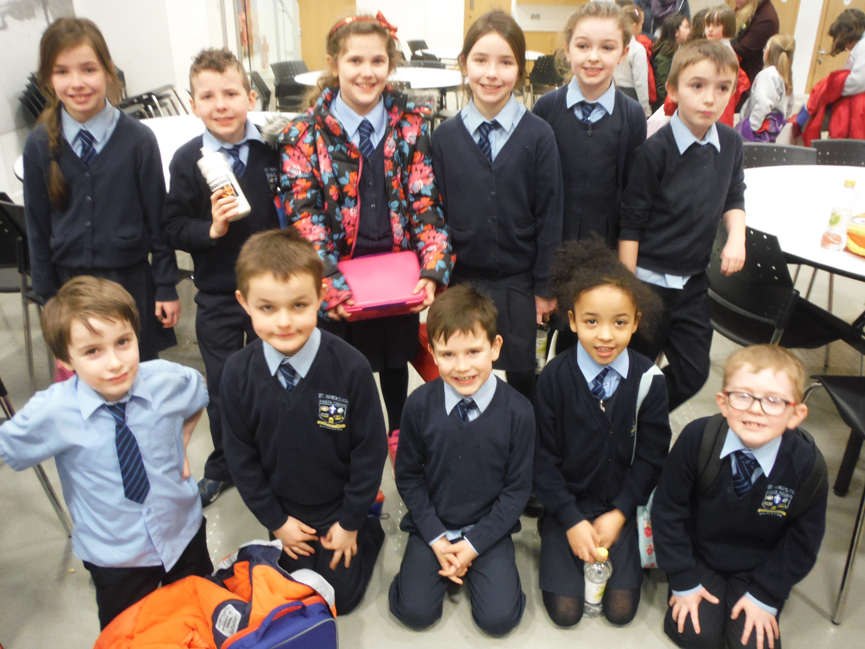

CHILD’S WRITTEN PIECE – Peadar O’Neill P5

“On Thursday 26th January we went to the Ulster Museum in Belfast. We travelled on a huge bus with Gortin Controlled School. On the bus I sat beside Sean. We were so hungry! Sean kept on asking if he could eat his lunch, but then when we got to Belfast we did get to eat a bit of lunch. At the museum there was an extraordinary dragon. I looked around and amazingly there was a huge cannon and also dinosaurs. We were split up – all the P4 class went together and all the P5 class went together. The P4’s went on their lecture first. We had to look at other things. Then we got our lunch. Then we went on our lecture. We learnt about how lava cools down and the different lava that erupts from volcanos and rocks.”

MID TERM & SCHOOL CLOSURES

School will be closed on Wednesday 15th to Friday 17th February inclusive.

POST-TRANSFER THOUGHTS



DATES FOR THE DIARY

CONFIRMATION | Sunday 2nd April 2017
FIRST CONFESSION | Monday 20th March 2017
FIRST COMMUNION | Sunday 4th June 2017
MID-TERM BREAK | Wed 15th, Thurs 16th & Friday 17th February
FUN RUN | Saturday 8th April 2017
GRANDPARENTS’ COFFEE  MORNING | Friday 10th February @11am

THOUGHT FOR TODAY



GRANDPARENTS’ COFFEE MORNING – FRIDAY 10TH FEBRUARY AT 11.00A.M.

NUMBER OF GRANDPARENTS ATTENDING:

NAME OF PUPIL (S) ______________________________

SIGNED ____________________________________________

