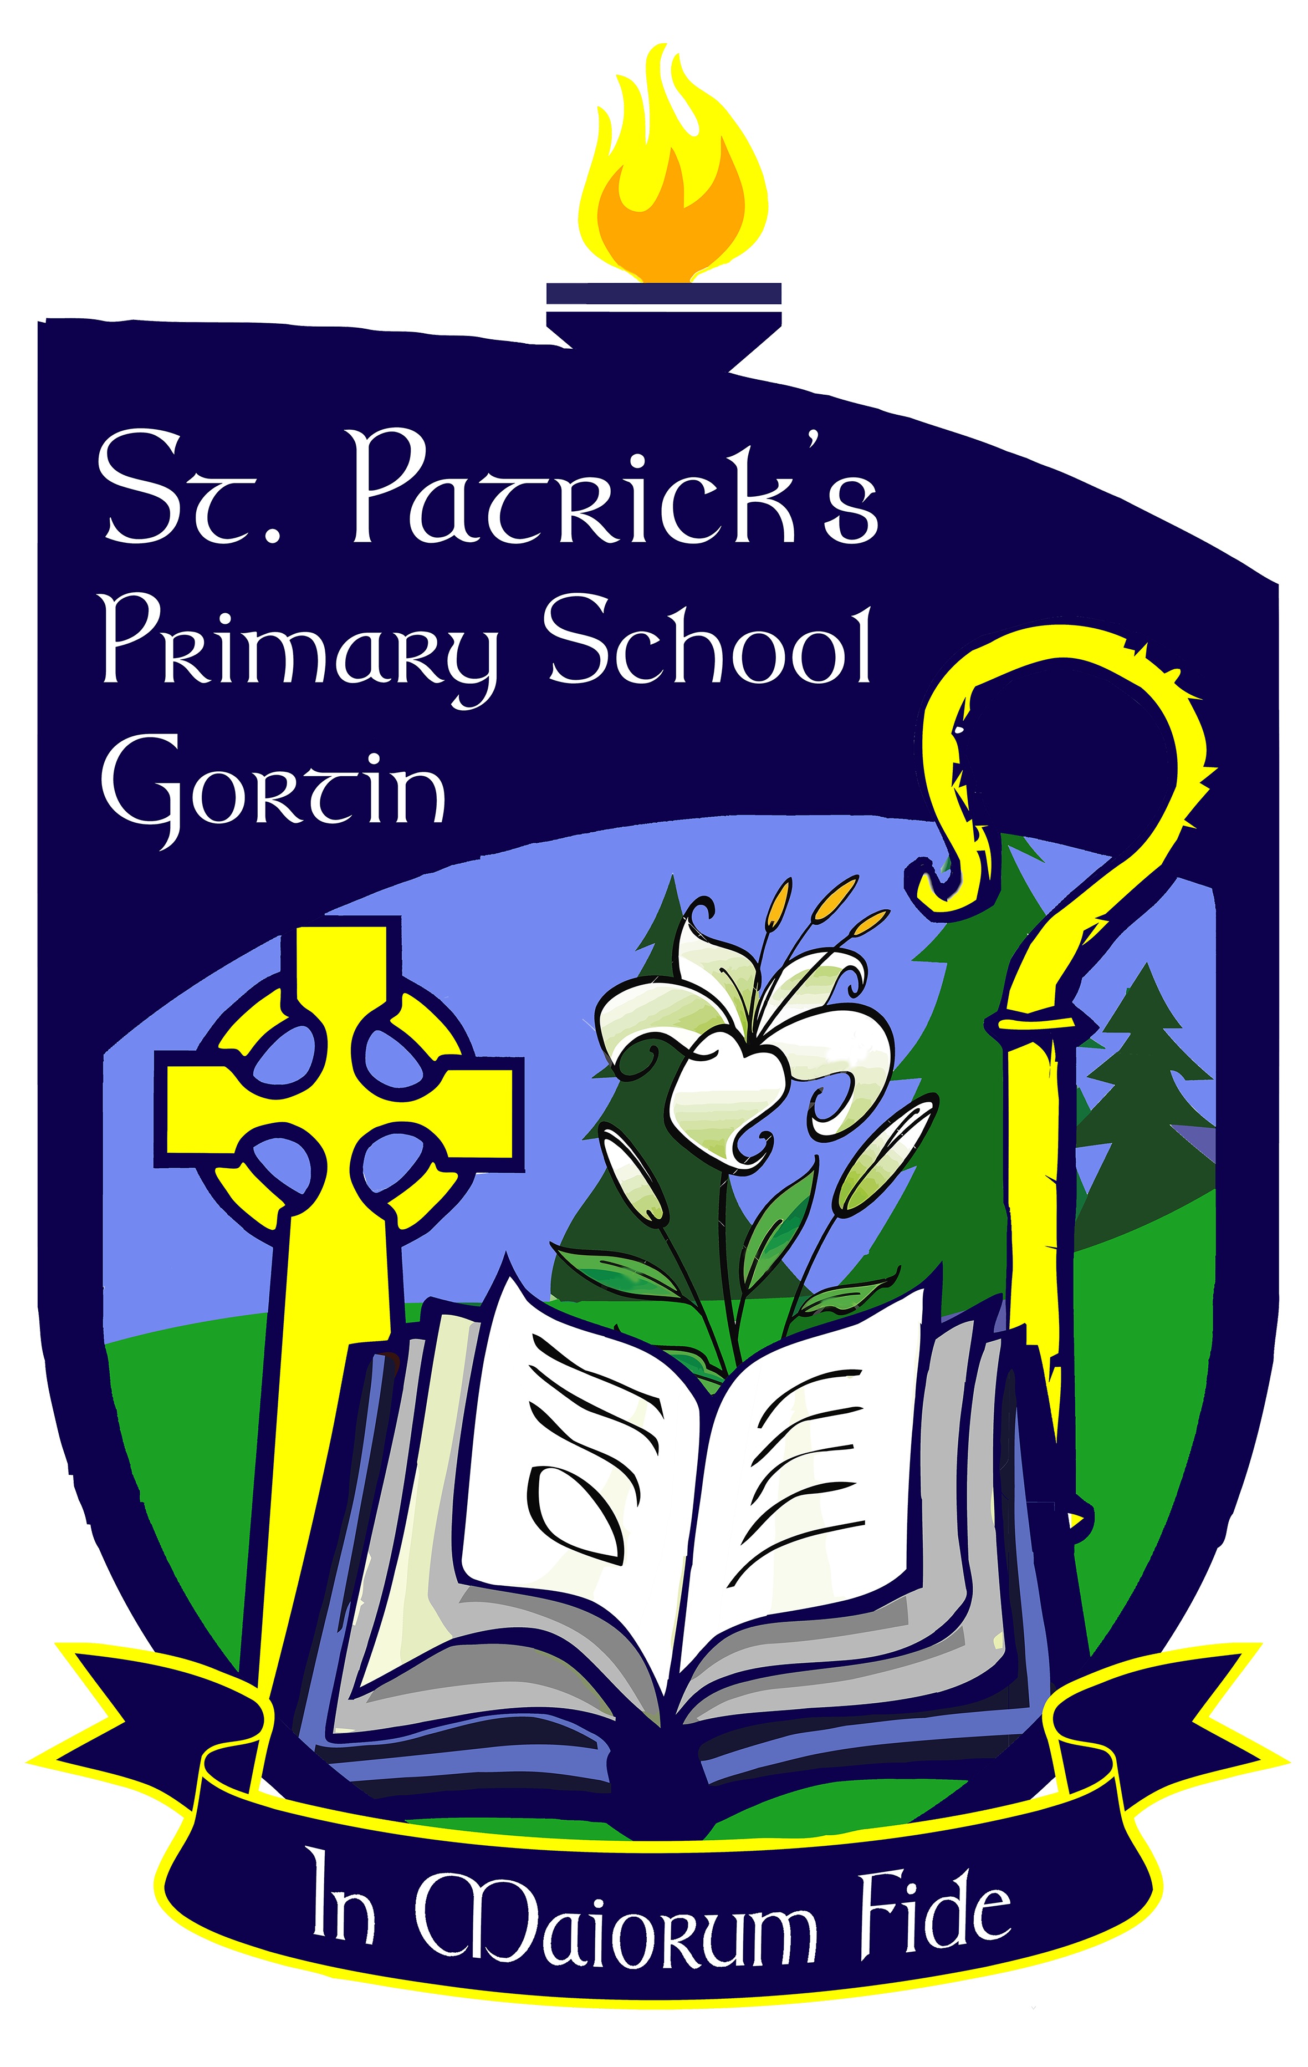

PARENTS NEWSLETTER JANUARY 2017

As we begin 2017 we would just like to firstly wish you all a happy, peaceful and healthy new year and wish all our pupils good health, fun learning and lots of success in 2017.

CHRISTMAS SHOW – A big thank you to everyone who came to our school Christmas Production “Cinderella.” It was a fantastic success and we hope you enjoyed it as much as the pupils enjoyed taking part. Thank you to all the staff who worked so hard as a team leading up to and on the night. Thanks also to Mrs Sweeney, past pupils and parents who helped on the night, the GAC and Fr Forbes for the use of the hall and the Owenkillew Centre who lent us decorations and costumes.

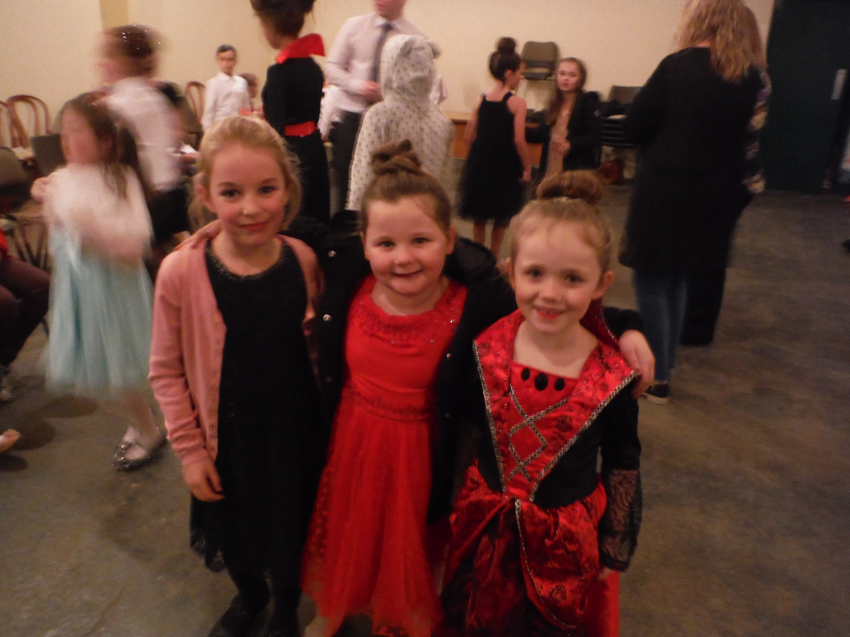
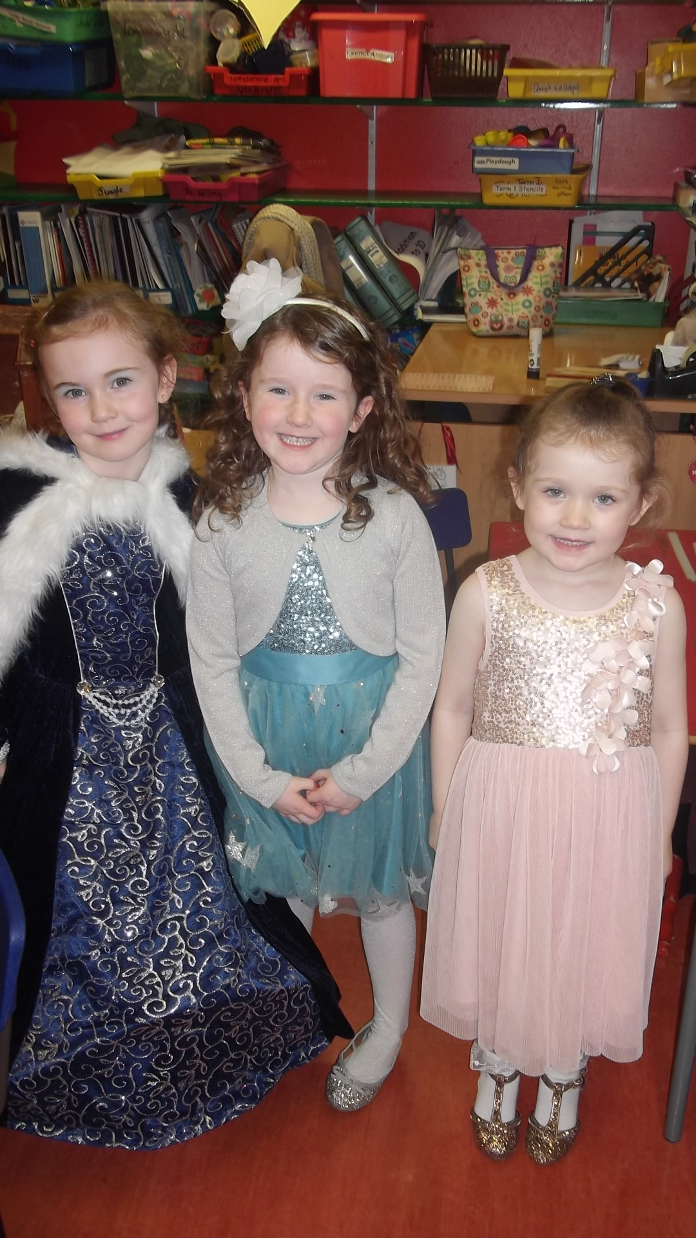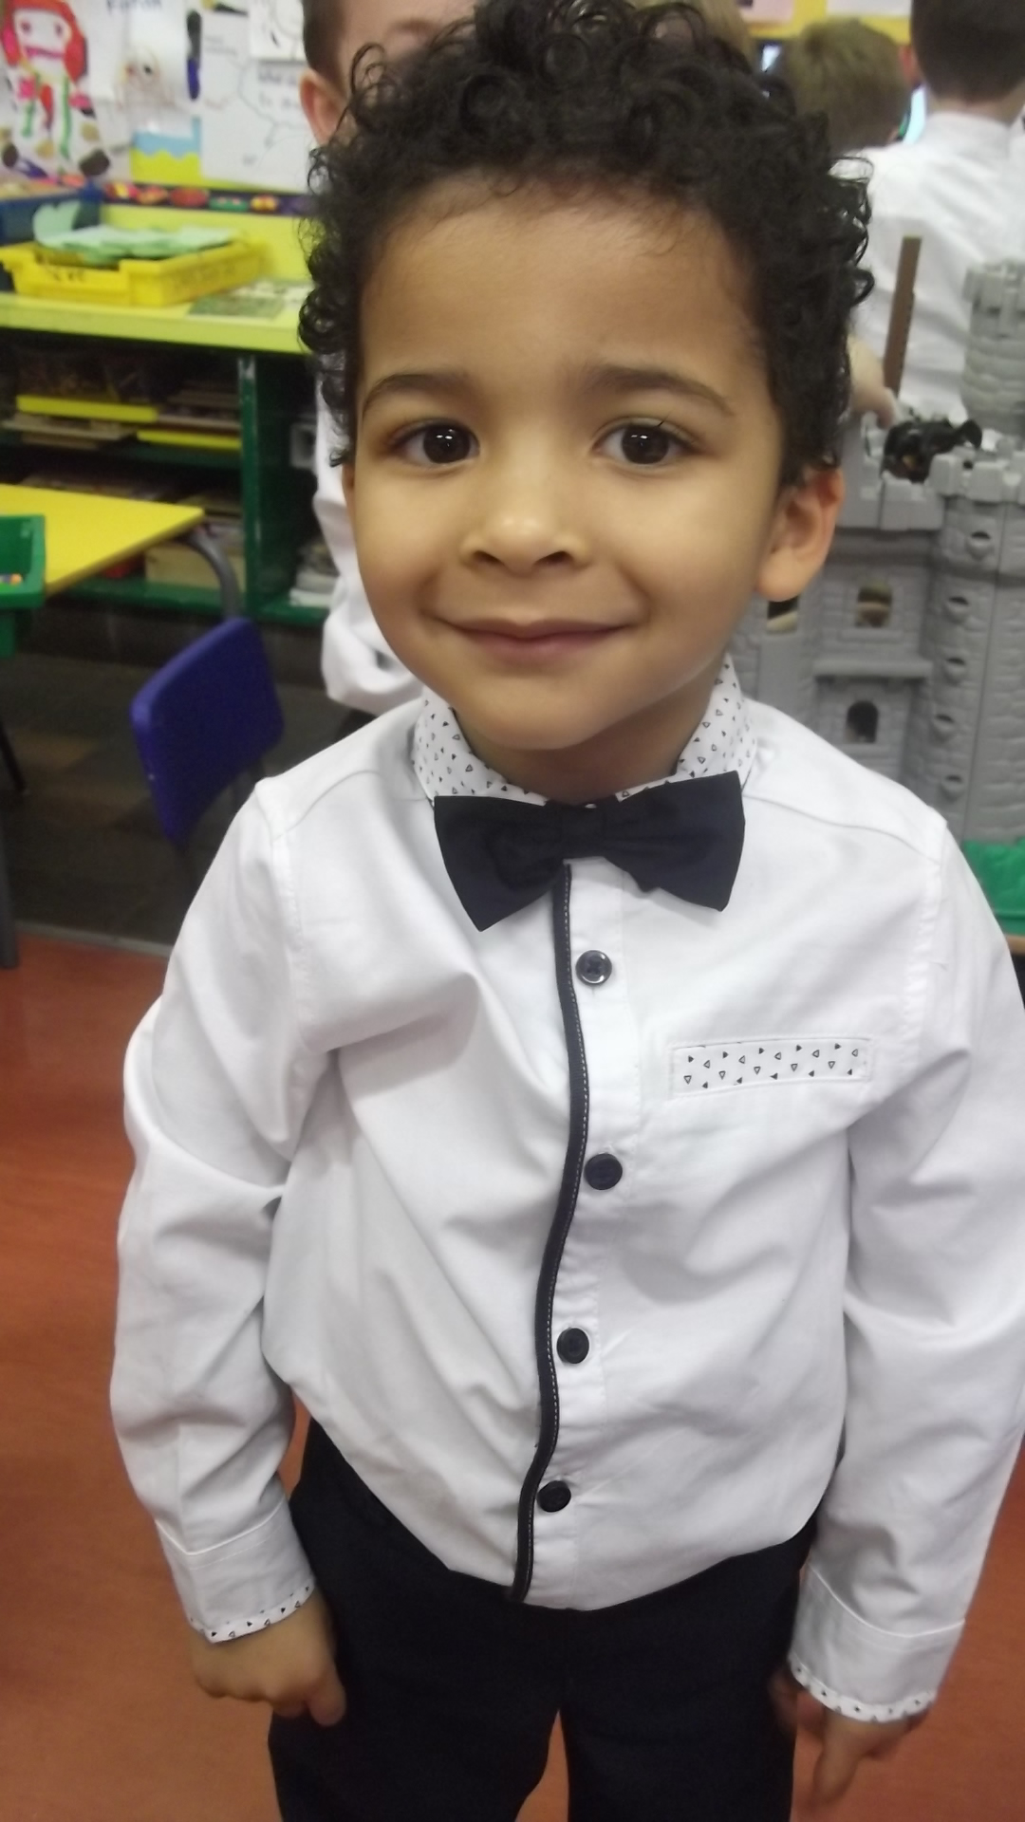

CINDERELLA POSTER WINNERS

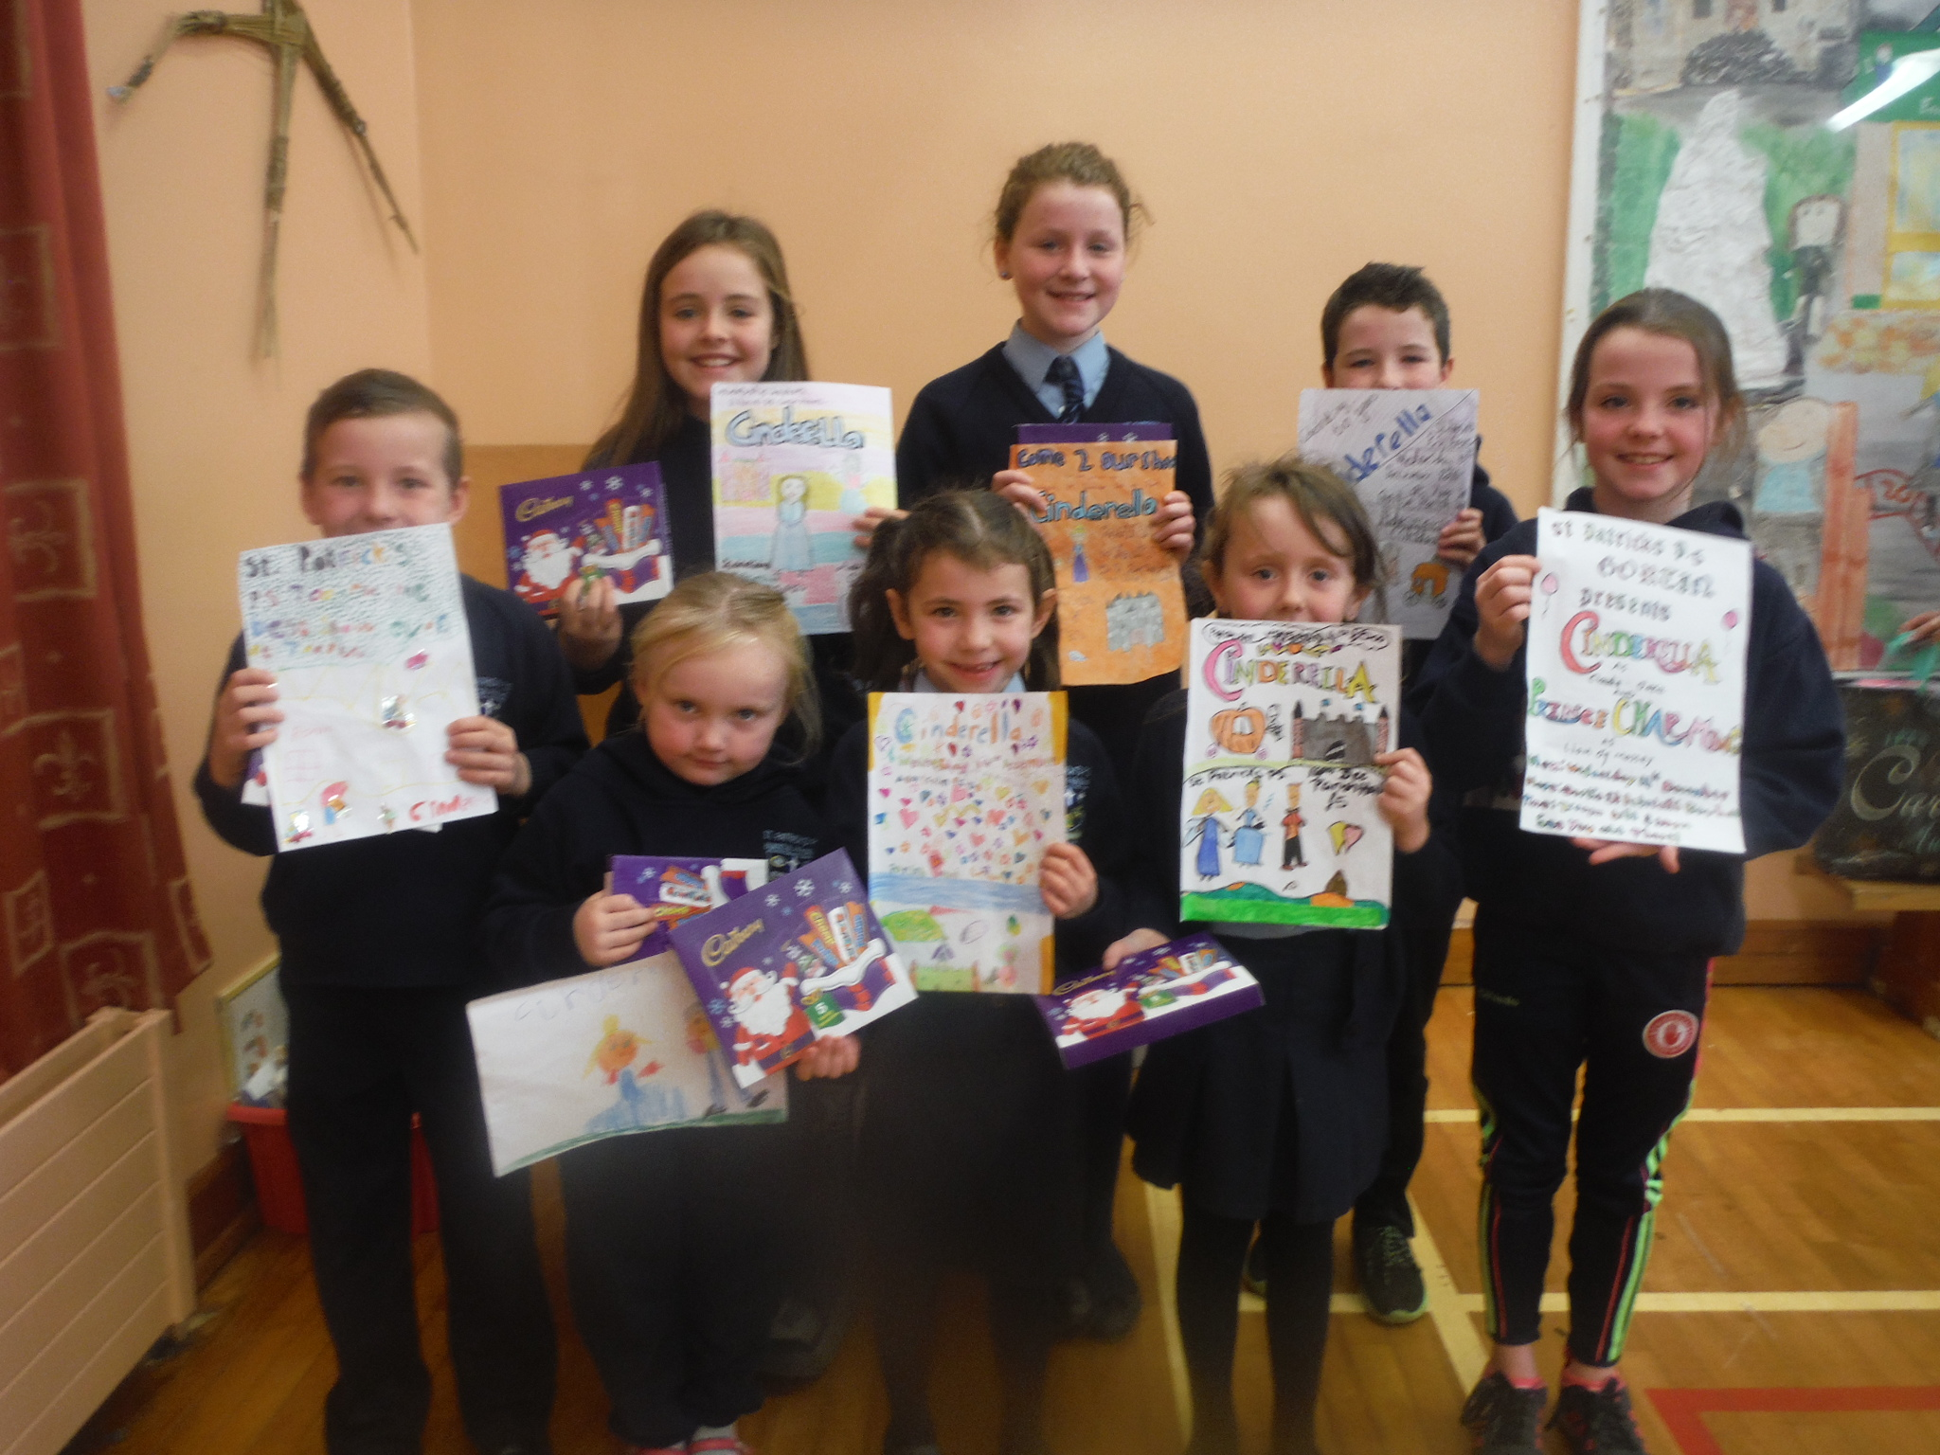

CHRISTMAS RAFFLE – A massive thanks to all those who donated and bought tickets. A fantastic sum of £1141.50 was raised – more details below.

 | DONATED BY:- | WINNER
1st Prize | £150 O’Neill’s Sports Voucher | Alaine Ward
2nd Prize | Christmas Hamper – donated by parents | Erinn Mc Cullagh P1
3rd Prize | 1 Year Lotto Subsciption + gloves donated by Badoney Ladies | Fr Francis Bradley
4th Prize | 1 year Lotto Subscription + tracksuit top donated by St Patrick’s Football Club | Mairtin Og Bradley
5th Prize | Foothills Voucher – donated by Foothills | Helen Wright

We also had many other donations from Parents, Staff and The Glenview Chippy, which we were delighted to receive.

We also had a raffle for the top ticket sellers in the school. The Ellis family and the Mc Connell family were the lucky winners of £15 Pizzarama vouchers!!


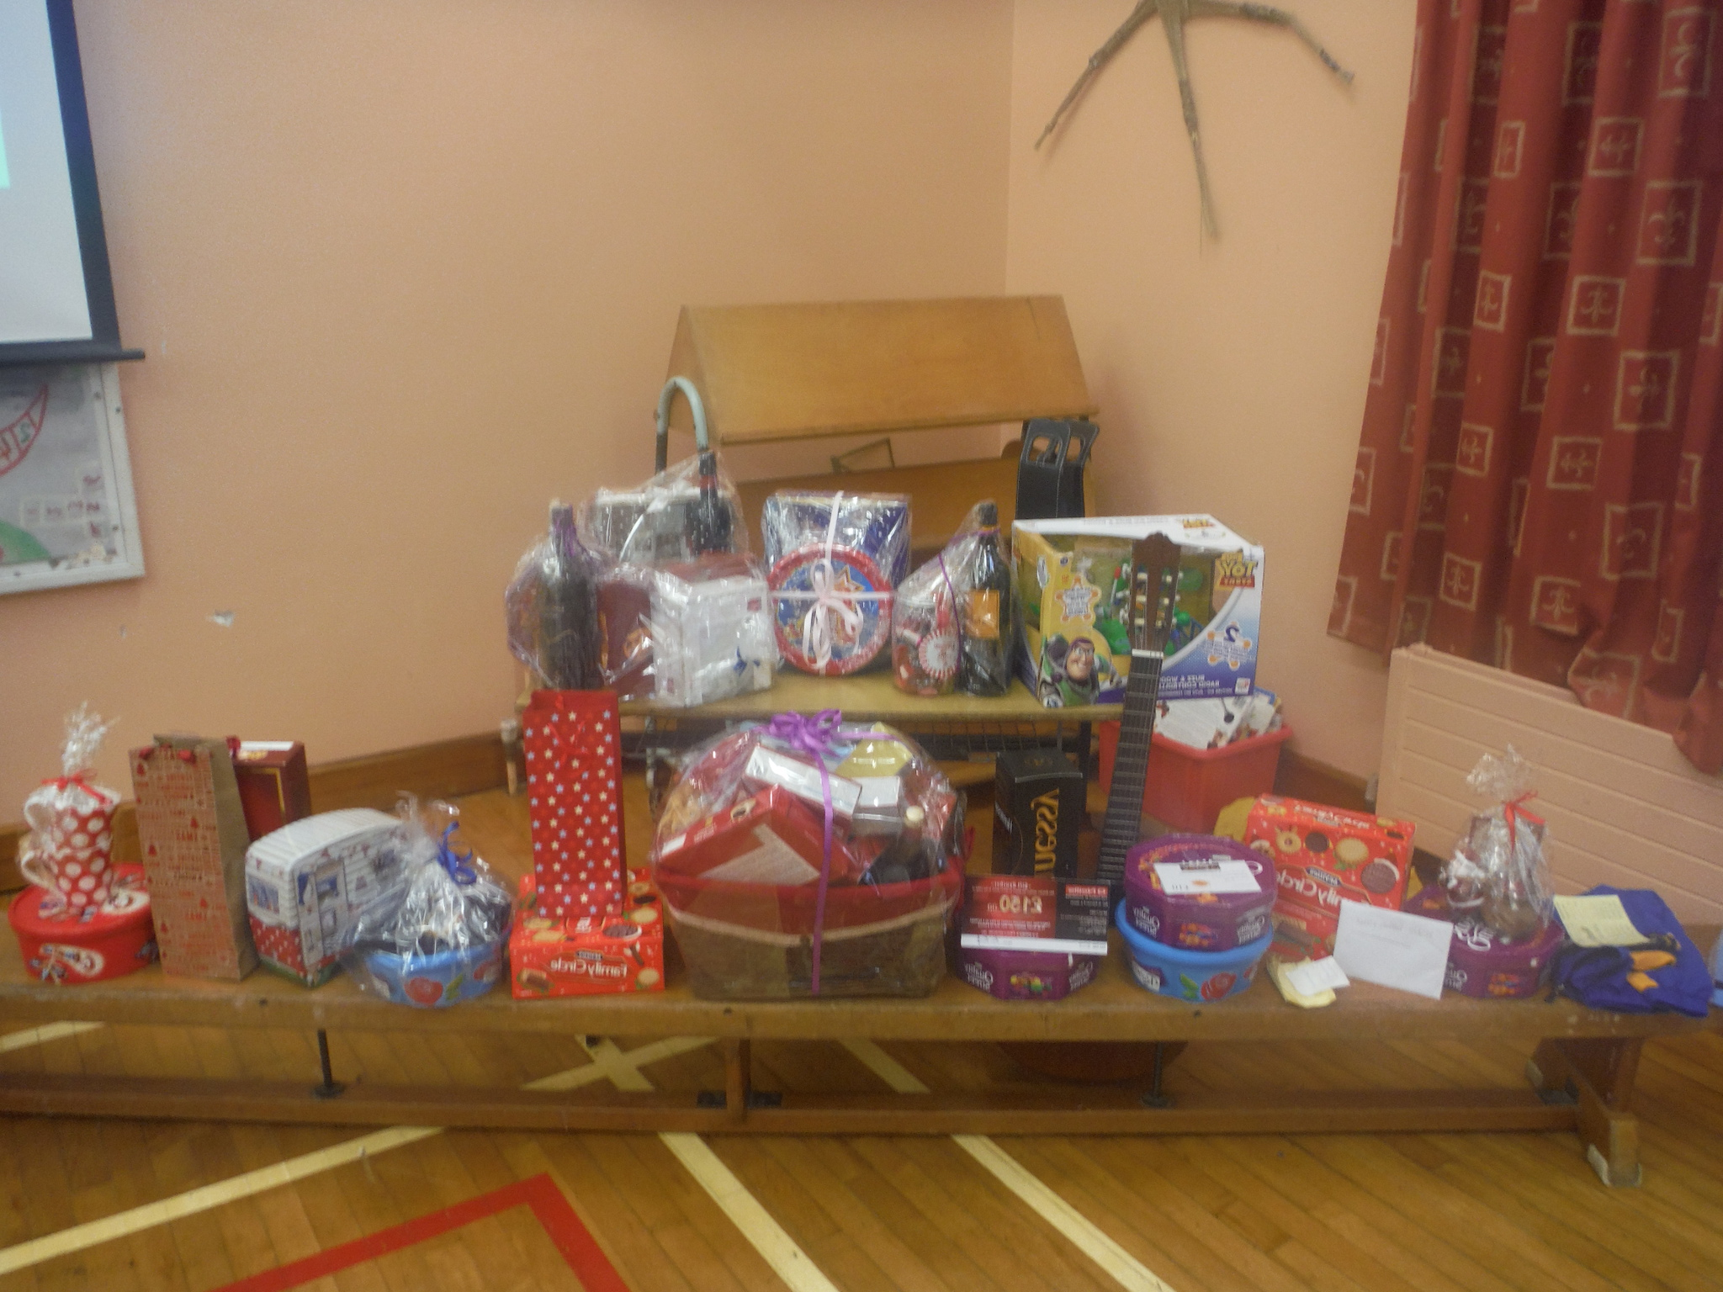

CANCER FOCUS PROGRAMME

Cancer Focus will be running some Health and Fitness Programmes in each class. This term the programme will include – P4/5 – Food detectives, P6/7 – Smoke busters.

CRUCIFIX PRESENTATION

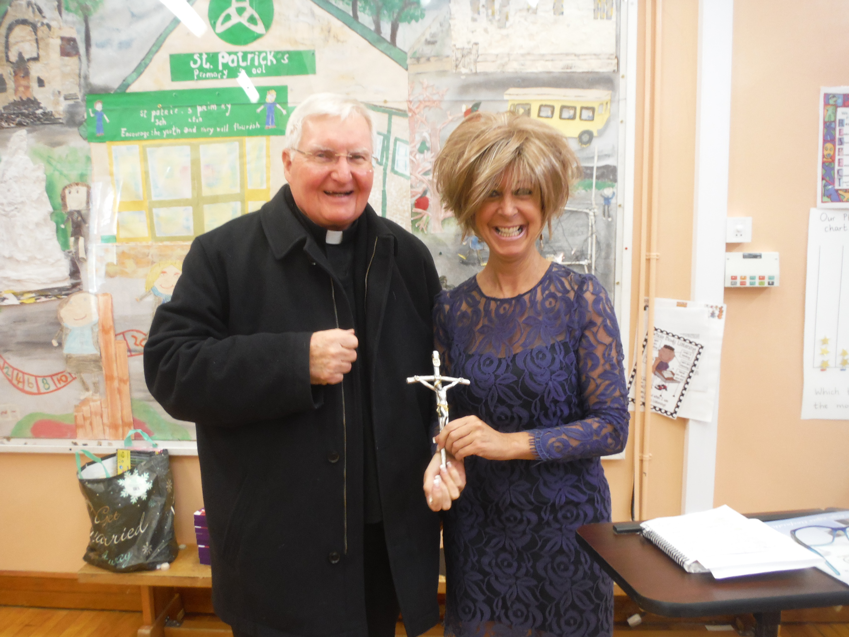

A big thanks to Fr Forbes who recently presented the school with a Crucifix which he purchased in Rome. It now takes pride of place in the school porch.

PRESENTATION IN STORMONT –

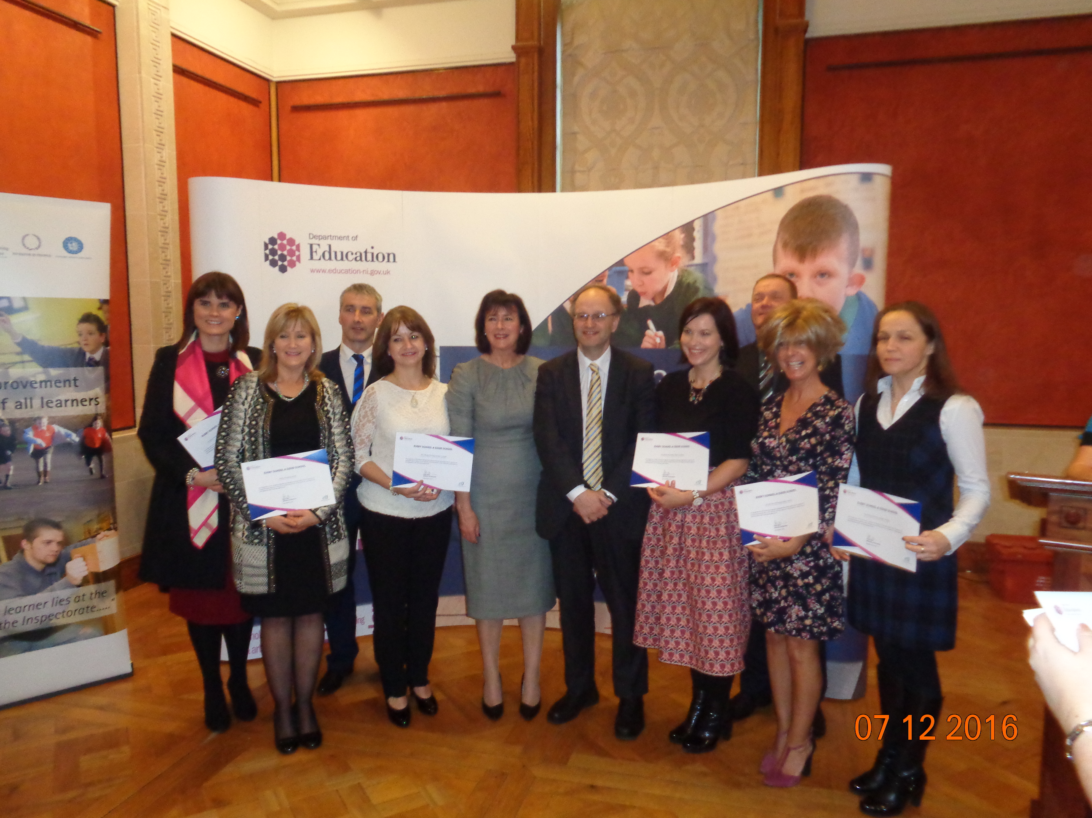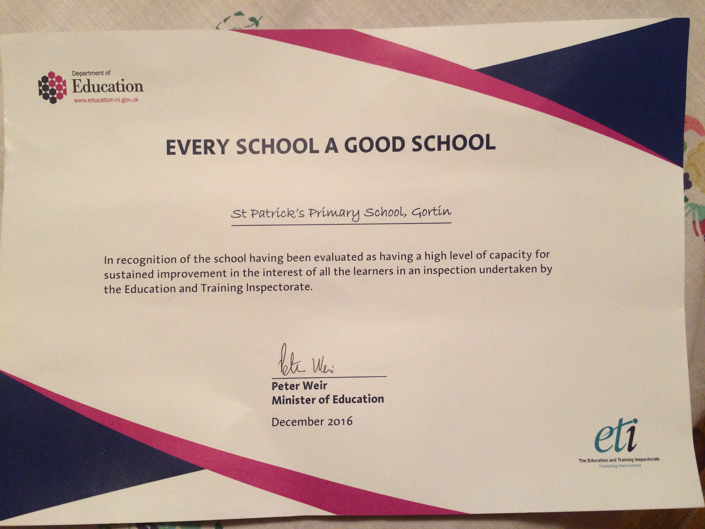

Mrs Grugan recently attended a presentation in Stormont with the Education Minister Peter Weir and Chief Inspector Noelle Buick, in recognition of the school having been evaluated as having a high level of capacity for sustained improvement in the interest of all learners in the recent ETI Inspection. Well done to all the staff, governors, parents and pupils – a great team effort!

CHRISTMAS BREAKFAST
A big thanks to our Breakfast Club Co-ordinator, Mrs McBride and Mrs Marlow for organising a very special Christmas Breakfast at the end of last term. Children enjoyed a scrumptious breakfast consisting of bagels, croissants, ham, egg, bacon,sausages,beans and juice - a menu which they chose themselves. A big achievement for such big numbers – well done everyone. We appreciate all those who supported our Breakfast Club last term – we have had a fantastic increase in numbers and outstanding feedback!

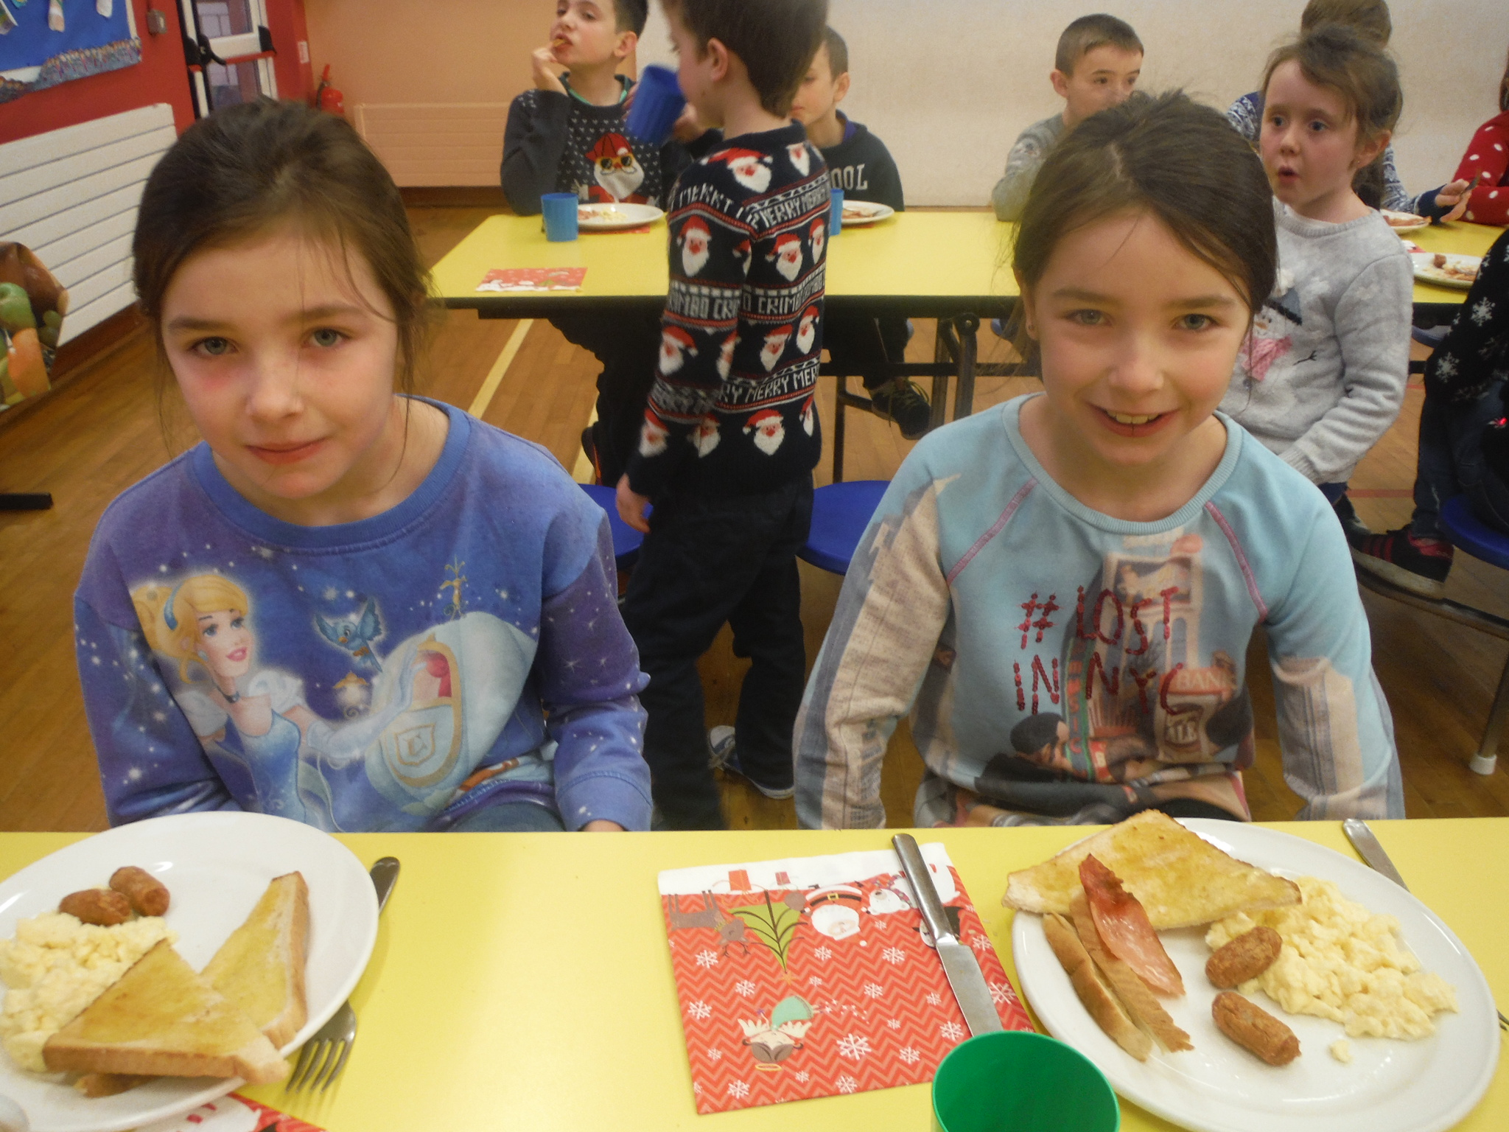

WEBSITE
Please keep up to date with all the events over the last few weeks on our website- www.stpatricksgortin.com

P6/7 SWIMMING - will begin on Tuesday 24th JANUARY. All monies- £30.00 per child, must be forwarded to the school by Monday 16th JANUARY. Please ensure your child brings their swimming kit to school each Tuesday to take part in the programme.

GRANDPARENTS’ DAY - Following on from the success of last year’s ‘Grandparents Tea Morning’, we are hoping to repeat it this year on Friday 10th FEBRUARY. Let’s hope for once, the weather doesn’t force us to reschedule! We also like to remember any Grandparents who have sadly passed away and we would really appreciate if a little photo could be sent in, before Monday 6th February to display on the day.

P1 APPLICATION FORMS FOR SEPTEMBER 2017
Anyone who has a child whose 4th birthday falls on or before 1st July 2013 and wishes to apply for a place in Primary 1, please contact the school for an application form if you haven’t already received one. Please let the school know of anyone of that age who is first in the family and may not be aware of the process.

SACRED HEART COLLEGE OPEN DAY - SATURDAY 14th JANUARY from 10.00am – 1.00pm. Please check press for details.

DEAN MAGUIRC COLLEGE OPEN DAY
P7 children will be going to the Dean on Monday 16th January. Children can wear their PE Uniform and the school provides transport and lunch.

PRINCIPAL AWARDS NOVEMBER / DECEMBER - AWARDED FOR DRAMA AND MUSIC.

P1 Cahir Conway & Ava Brogan
P2 Eimhear-Grace Finlay
P3 Anna Kelly
P4 Ellie Daly
P5 Michael McGarvey
P6 Lucas McGarvey & Nicole McCallion
P7 Alannah McCarron & Rubi McGarvey

MONIES DUE FOR TERM 2

SPORTS COACH (ROBBIE | P1-P7 | £6.00 per term
DINNERS NEW COST FROM 1st JANUARY 2017 | £ 2.55 PER DAY | £12.75 per week
MILK (per term) | Beginning Tuesday 24th January to Wednesday 12th April inclusive | £10.40 per pupil
MUSIC (per term) with Mrs Sweeney | FOR P1-P7. | £8.00 per pupil
TOTALS – MILK, MUSIC AND ROBBIE FOR TERM 2 = £ 24.40 + (DINNERS EXTRA!)
MUSIC AND ROBBIE - £ 14.00

PLEASE FORWARD TO THE SCHOOL ON OR BEFORE MONDAY 23RD JANUARY 2017. MILK CAN ONLY BE ORDERED BY THOSE WHO HAVE PAID BY THIS DATE. Please ask your child if they are drinking their milk before ordering it as we have discovered a lot of children are throwing half or full cartons away on a daily basis.

MILK BEGINS ON TUESDAY 24TH JANUARY 2017

Please note the new cost for school meals will increase on 1st January, from £2.50 to £2.55.

AFTERSCHOOLS PROGRAMME – Information will be forwarded at a later stage.

ROCKS AND LANDSCAPES-P4/5 trip – Thursday 26th January

As part of their Shared Education World Around Us Topic, Rocks and Landscapes, P4/5 pupils will travel to the Ulster Museum in Belfast with Gortin Controlled PS to view the Rocks and Landscapes exhibition..
Pupils must wear uniform on this day and bring a lunch..

TEACHERS' INDUSTRIAL ACTION

All teachers are presently involved in Industrial Action linked to the 'Enough is Enough' campaign and Teachers' Salaries.
As part of this, there will be a half day teachers' strike on Wednesday 18th January...MORE DETAILS WILL FOLLOW CLOSER TO THE TIME..

THOUGHT FOR 2017



